Knowledge Discovery in Databases (KDD) Methodology
Applied if the system involves data analytics or forecasting. It follows stages from raw data to usable patterns.
What data?
The primary dataset for this study consists of historical transaction records obtained from the POS system of Banelo Bake and Brew. The data includes essential fields such as product names, categories, quantities sold, unit prices, total sales per transaction, inventory levels, and transaction timestamps. These attributes were chosen for their direct relevance to sales behavior and forecasting accuracy. Although promotional data is not available, time-based attributes like weekdays, weekends, and months are considered to capture periodic fluctuations in customer demand.
Dataset Characteristics:
Total Records: 3,311 sales transactions
Time Span: 407 days of historical data
Date Range: Comprehensive coverage of daily sales patterns

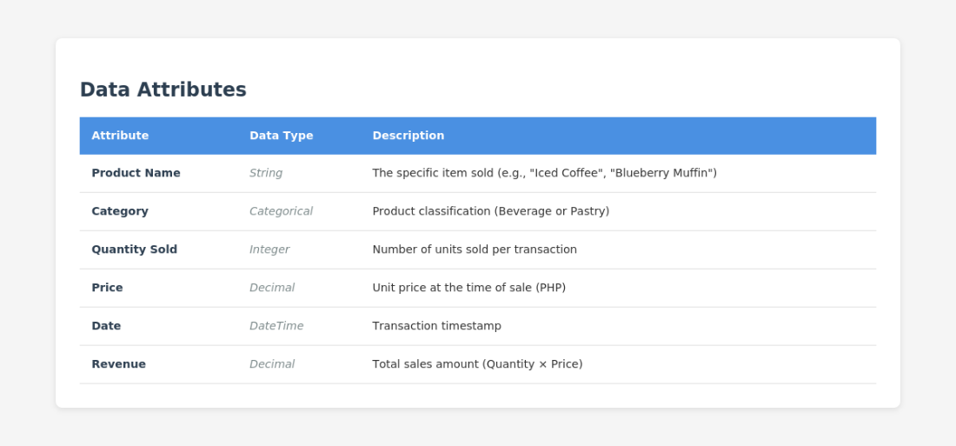
Data Attributes:

Figure 44. Data Attributes

How did I prepare it?
Data preparation began with preprocessing, which involves cleaning the raw dataset to ensure consistency, completeness, and accuracy. This includes removing duplicate entries, correcting inconsistent product codes or labels, standardizing date formats, and addressing any missing or null values in key fields. After cleaning, the data underwent a transformation to make it suitable for mining. This involves aggregating daily sales into weekly or monthly totals to smooth short-term noise, generating lag features (e.g., sales from previous days or weeks), and creating rolling averages to highlight trends. Additionally, categorical fields like product categories were encoded numerically using techniques such as one-hot encoding. Time-based features such as day of the week, month, or whether the date falls on a weekend, is also engineered to help the model detect seasonal and behavioral sales patterns.

What model I used?
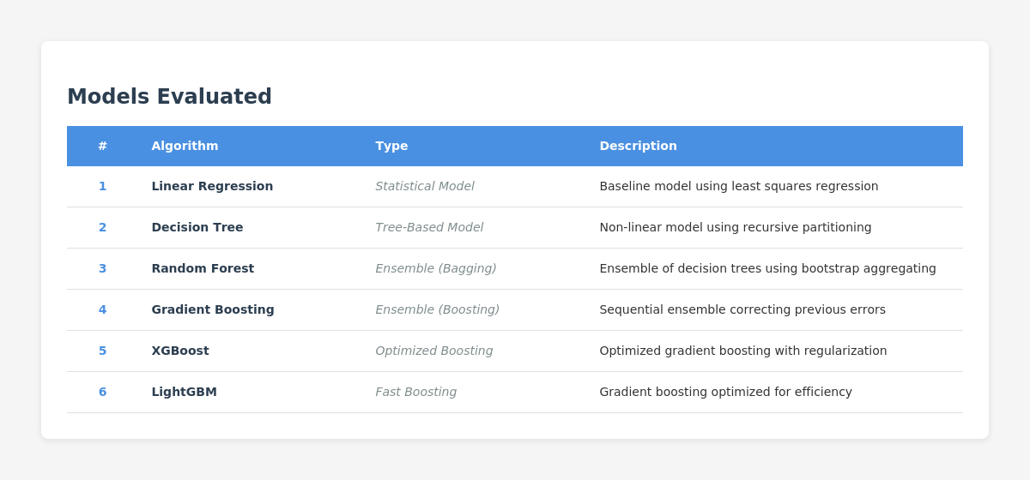
To ensure the selection of the most accurate forecasting model, a systematic comparative evaluation was conducted across six (6) different machine learning algorithms. This rigorous approach aligns with best practices in predictive analytics and provides empirical justification for model selection.

Figure 45. Models Evaluated

Model Training Methodology
All models were trained using a consistent, fair comparison methodology:
Training Set: 80% of historical data (oldest 2,649 records)
Testing Set: 20% of historical data (most recent 662 records)
Validation Strategy: Temporal split to prevent data leakage and simulate real-world forecasting
Feature Set: Identical 10+ engineered features used across all models
Random Seed: Fixed seed (42) for reproducibility

Evaluation Metrics
Model performance was assessed using four industry-standard regression metrics:

1. Mean Absolute Error (MAE)
- Measures the average absolute difference between predicted and actual values
- Expressed in the same units as the target variable (quantity sold)
- Lower values indicate better accuracy
MAE = (1/n) × Σ|yᵢ - ŷᵢ|

Where:
- n = number of observations
- yᵢ = actual value
- ŷᵢ = predicted value
- |...| = absolute value

2. Root Mean Squared Error (RMSE)
- Penalizes larger errors more heavily than MAE due to squaring
- Provides insight into model robustness against large prediction errors
- More sensitive to outliers than MAE
RMSE = √[(1/n) × Σ(yᵢ - ŷᵢ)²]

Where:
- n = number of observations
- yᵢ = actual value
- ŷᵢ = predicted value
- √ = square root

3. Mean Absolute Percentage Error (MAPE)
- Expresses prediction error as a percentage of actual values
- Scale-independent metric enabling comparison across different datasets
- Lower percentages indicate higher forecasting accuracy

MAPE = (100/n) × Σ|(yᵢ - ŷᵢ) / yᵢ|

Where:
- n = number of observations
- yᵢ = actual value
- ŷᵢ = predicted value
- |...| = absolute value
- Result is expressed as a percentage (%)

4. R² Score (Coefficient of Determination)
- Measures the proportion of variance in sales explained by the model
- Ranges from -∞ to 1.0, with values closer to 1.0 indicating better explanatory power
- Negative values indicate predictions worse than the mean baseline
R² = 1 - (SS_res / SS_tot)

Where:
- SS_res = Σ(yᵢ - ŷᵢ)² (Residual Sum of Squares)
- SS_tot = Σ(yᵢ - ȳ)² (Total Sum of Squares)
- yᵢ = actual value
- ŷᵢ = predicted value
- ȳ = mean of actual values

Alternative formula:
R² = 1 - [Σ(yᵢ - ŷᵢ)² / Σ(yᵢ - ȳ)²]

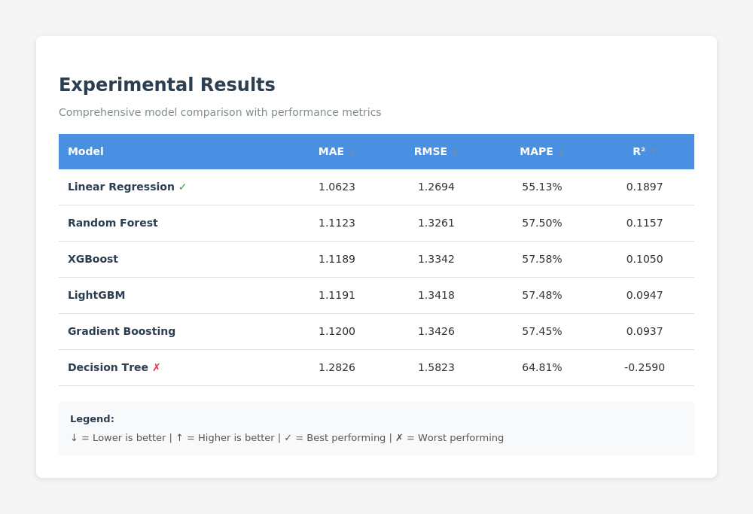
Experimental Results

Figure 46. Experimental Results

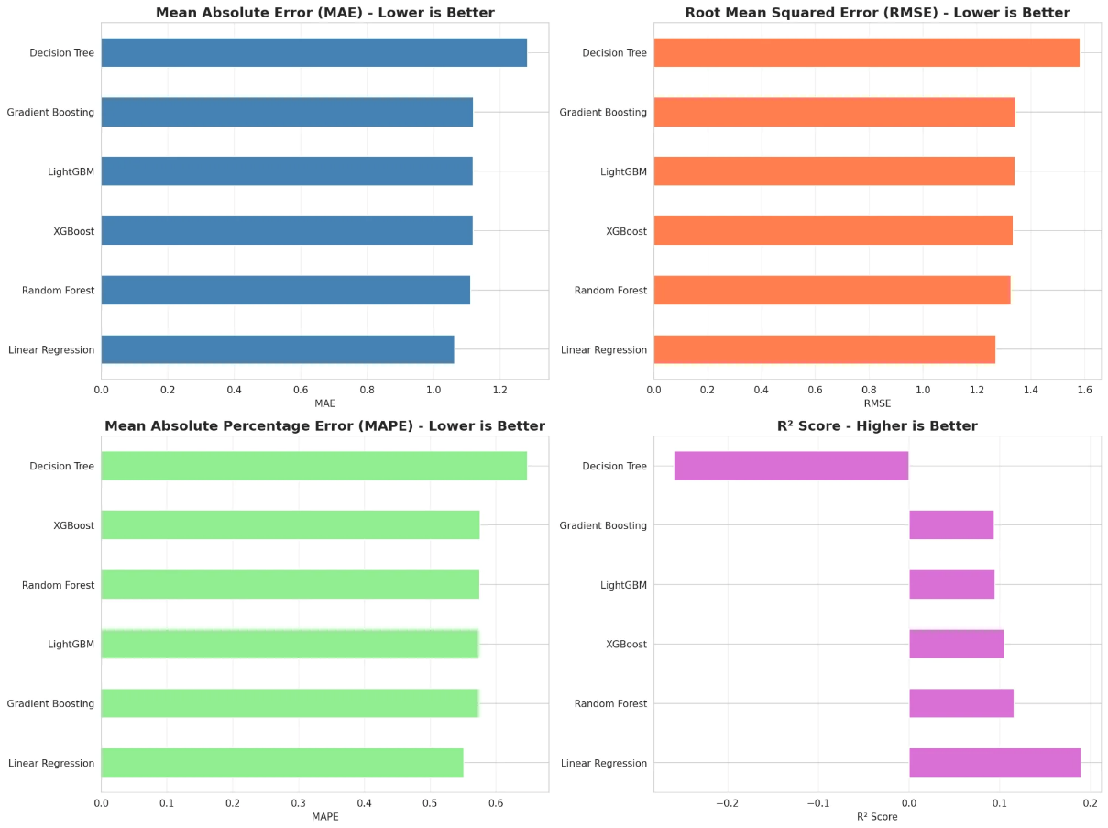
Figures 47-50. Experimental Results
The visualization above presents a comprehensive comparison of all six models across four evaluation metrics. Linear Regression demonstrates superior performance with the lowest error rates (MAE, RMSE, MAPE) and highest explanatory power (R²).

Key Findings
1. Mean Absolute Error (MAE) Results
MAE measures the average prediction error in units sold. Linear Regression achieved the best MAE of 1.0623, followed closely by ensemble methods (1.11-1.12), while Decision Tree performed worst at 1.2826. This metric is crucial for inventory management as it directly indicates potential stock discrepancies.
2. Root Mean Squared Error (RMSE) Results
RMSE penalizes large errors more heavily than MAE. Linear Regression obtained the lowest RMSE of 1.2694, demonstrating consistent predictions. Decision Tree's RMSE of 1.5823 indicates greater variability and occasional large forecasting
3. Mean Absolute Percentage Error (MAPE) Results
MAPE expresses errors as percentages, making it easily interpretable. Linear Regression achieved 55.13% MAPE, while ensemble methods ranged from 57.45-57.58%, and Decision Tree reached 64.81%. These moderate values indicate the models capture general trends but suggest room for improvement in precise predictions.
4. R² Score (Coefficient of Determination) Results
R² measures the proportion of variance explained by the model. Linear Regression achieved the highest R² of 0.1897 (19%), while ensemble methods ranged from 0.09-0.12. Decision Tree's negative R² (-0.2590) indicates predictions worse than the mean baseline, revealing severe overfitting.
5. Overall Results
Linear Regression emerged as the optimal model, consistently outperforming all competitors across all metrics. Despite its simplicity, it achieved superior accuracy, suggesting the sales data exhibits predominantly linear patterns. The ensemble methods showed similar performance to each other but were marginally inferior to Linear Regression. Decision Tree's poor performance, particularly its negative R², demonstrates severe overfitting.
Linear Regression was selected for deployment due to its best balance of accuracy, interpretability, computational efficiency, and ease of implementation—critical factors for real-world POS system integration.

Linear Regression
Linear Regression (LR) is applied as the forecasting model to predict sales by examining the relationship between one or more independent variables and a dependent variable. LR is widely recognized for its ability to estimate how predictor variables influence an outcome variable, making it particularly suitable for sales forecasting applications.
According to Kohli et al. (2020), linear regression proves effective for sales prediction due to its simplicity and interpretability, allowing businesses to understand the direct relationship between input features and sales outcomes. Similarly, research by Takale et al. (2022) demonstrated that linear regression serves as a reliable predictive model for sales forecasting, particularly when historical sales data exhibits linear patterns and relationships.
In retail forecasting, linear regression has shown consistent performance across various applications. A study on weekly sales forecasting by Behera et al. (2022) compared multiple regression techniques including linear regression, lasso, ridge, random forest, decision tree, and XGBoost. Their findings indicated that while ensemble methods can capture complex patterns, linear regression remains competitive, especially when the underlying data relationships are predominantly linear. The model's transparency and computational efficiency make it particularly valuable for real-time forecasting systems in point-of-sale environments.
Furthermore, research on Walmart sales prediction by Kumar et al. (2025) employed linear regression alongside advanced machine learning algorithms to forecast weekly sales. Although ensemble methods like Random Forest and XGBoost showed superior performance in their study, linear regression provided valuable baseline predictions with significantly lower computational requirements, making it practical for resource-constrained retail environments.
In the case of Banelo Bake and Brew, the researcher examined factors such as day of the week, promotional activities, seasonal trends, and available stock, with sales as the primary
variable to measure. With the use of Linear Regression, the system can analyze how these factors affect sales performance and generate accurate forecasts for inventory planning.
The model assumes a linear relationship, mathematically expressed as:
ŷᵢ = β₀ + β₁x₁ᵢ + β₂x₂ᵢ + ... + βₚxₚᵢ + εᵢ
Where:
• ŷᵢ = predicted value (e.g., sales)
• β₀ = intercept (baseline sales when all predictors are zero)
• β₁, β₂, ..., βₚ = coefficients of predictors (effect of each variable on sales)
• x₁ᵢ, x₂ᵢ, ..., xₚᵢ = independent variables (e.g., day of week, promotions, stock levels)
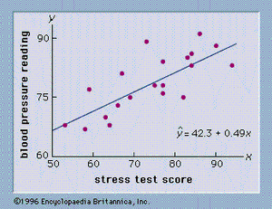
• εᵢ = error term (unexplained variation)
Figure 51. Multiple Linear Regression Model
• How did I measure the performance?
The accuracy of the Linear Regression model are assessed using Mean Absolute Error (MAE), Root Mean Squared Error (RMSE), Mean Absolute Percentage Error (MAPE), and the R² Score. These metrics help determine whether the model reliably explains sales patterns and provides consistent predictions. Residual analysis has also been conducted to verify that linearity and other regression assumptions hold true.
• How are the results shown?
Results are presented through line graphs comparing actual versus predicted sales values over time, along with residual scatter plots to visualize model performance. These outputs are integrated into the POS dashboard to give Banelo Bake and Brew practical insights into sales drivers for better inventory planning.
By applying these models, the proposed POS and inventory management system does not only record and track sales but also generate meaningful forecasts that support proactive decision-making. This integration ensures that Banelo Bake and Brew can optimize stock management, reduce waste, and meet customer demand more effectively. Ultimately, the use of machine learning in forecasting strengthens the system’s capability to provide data-driven insights that improve both operational efficiency and business growth.

